MIME Protocol

MIME stands for Multipurpose Internet Mail Extensions. It is used to extend the capabilities of Internet e-mail protocols such as SMTP. The MIME protocol allows the users to exchange various types of digital content such as pictures, audio, video, and various types of documents and files in the e-mail. MIME was created in 1991 by a computer scientist named Nathan Borenstein at a company called Bell Communications.

MIME is an e-mail extension protocol, i.e., it does not operate independently, but it helps to extend the capabilities of e-mail in collaboration with other protocols such as [SMTP](https://www.javatpoint.com/simple-mail-transfer-protocol). Since MIME was able to transfer only text written file in a limited size English language with the help of the internet. At present, it is used by almost all e-mail related service companies such as Gmail, Yahoo-mail, Hotmail.

Need of MIME Protocol

MIME protocol is used to transfer e-mail in the computer network for the following reasons:

1. The MIME protocol supports multiple languages in e-mail, such as Hindi, French, Japanese, Chinese, etc.
2. Simple protocols can reject mail that exceeds a certain size, but there is no word limit in MIME.
3. Images, audio, and video cannot be sent using simple e-mail protocols such as SMTP. These require MIME protocol.
4. Many times, emails are designed using code such as HTML and CSS, they are mainly used by companies for marketing their product. This type of code uses MIME to send email created from HTML and CSS.

MIME Header

MIME adds five additional fields to the header portion of the actual e-mail to extend the properties of the simple email protocol. These fields are as follows:

1. MIME Version
2. Content Type
3. Content Type Encoding
4. Content Id
5. Content description

**1. MIME Version**

It defines the version of the MIME protocol. This header usually has a parameter value 1.0, indicating that the message is formatted using MIME.

**2. Content Type**

It describes the type and subtype of information to be sent in the message. These messages can be of many types such as Text, Image, Audio, Video, and they also have many subtypes such that the subtype of the image can be png or jpeg. Similarly, the subtype of Video can be WEBM, MP4 etc.

**3. Content Type Encoding**

In this field, it is told which method has been used to convert mail information into ASCII or Binary number, such as 7-bit encoding, 8-bit encoding, etc.

**4. Content Id**

In this field, a unique "Content Id" number is appended to all email messages so that they can be uniquely identified.

**5. Content description**

This field contains a brief description of the content within the email. This means that information about whatever is being sent in the mail is clearly in the "Content Description". This field also provides the information of name, creation date, and modification date of the file.

**Example of Content description**

Content-Description: attachment; filename = javatpoint.jpeg;  
modification-date = "Wed, 12 Feb 1997 16:29:51 -0500";

Working diagram of MIME Protocol

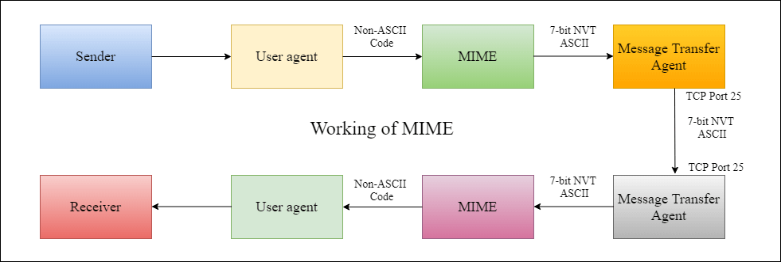

Features of MIME Protocol

1. It supports multiple attachments in a single e-mail.
2. It supports the non-ASCII characters.
3. It supports unlimited e-mail length.
4. It supports multiple languages.

Advantage of the MIME

The MIME protocol has the following advantages:

1. It is capable of sending various types of files in a message, such as text, audio, video files.
2. It also provides the facility to send and receive emails in different languages like Hindi, French, Japanese, Chinese etc.
3. It also provides the facility of connecting HTML and CSS to email, due to which people can design email as per their requirement and make it attractive and beautiful.
4. It is capable of sending the information contained in an email regardless of its length.
5. It assigns a unique id to all e-mails.